City of Kirby Bulk and Brush Collection Update- April 10, 2024
Today the City of Kirby was informed by Republic Waste Services that they are behind in their bulk and brush collection schedule. They are setting aside additional time for our residents.
- Section 1: Bulk and Brush Pick-Up has been extended to Friday, April 12, 2024; and
- Section 2: Bulk and Brush Pick-Up will begin on Monday, April 15, 2024- end on Friday April 19, 2024
- Republic Waste Services is requesting your assistance from our citizens to ensure that bulk and brush is not blocked by parked vehicles. Thank You.

- Brush/Bulky Guidelines:
- Limit your brush pile to five(5) cubic yards.
  - To determine the cubic yards, take the Length x Width x Height of the pile and divide by 27. (This will equal the cubic yards for example 5ft long by 5ft Wide by 5ft High = 125 divided by 27 equals 4.63 cubic yards.
- Brush must be placed within eight (5) feet of the curb.
- Do not place brush piles in front of parked cars, near fences, trees, mailboxes, beneath overhead wires, low-hanging tree limbs, or on top of gas/water meters.
- If glass windows or doors are placed at the curb, they must be taped up to prevent it from shattering upon pickup
- Brush must be set out no later than 7:00 a.m. on the first day of your scheduled collection week.
- Do not place material at the curb after crews have passed by your house.
Accepted Materials
- Shrubs, Tree Branches, Woody Vines, Other herbaceous and woody plants, BBQ grills (without compressed gas tanks), Carpeting, Fencing, Furniture, Mattresses, Toilets, Water heaters, Appliances***
***Refrigerators, freezers, and a/c window units will be collected only if refrigerant has been removed and the appliance is tagged and certified, indicating removal of refrigerant***

Materials Not Accepted
- Household Trash, Construction Debris –(This includes, but is not limited to, brick, concrete, other masonry materials, stone, glass, drywall, framing and finishing lumber, roofing materials, plumbing fixtures, HVAC equipment, insulation, and wall-to-wall carpeting), Hazardous Materials (paints, household cleaners, oil,), Compressed Gas Tanks, Tires, Televisions, Electronics, Computers, Medical Waste, Appliances with refrigerant that has not been removed and certified. Automotive parts or any machinery that may contain gasoline or oil.

Sector 1- April 1st – 12th
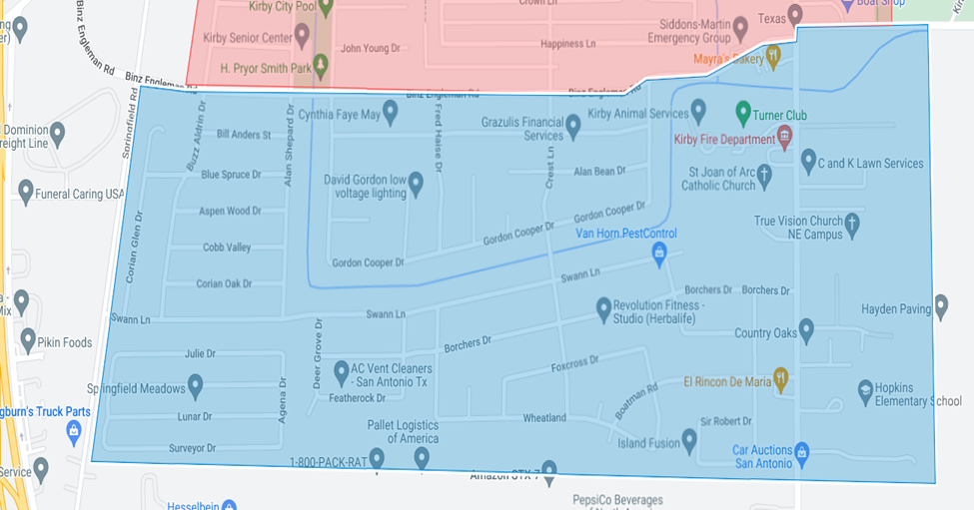
Sector 2- April 15 ^{th}- 19th 