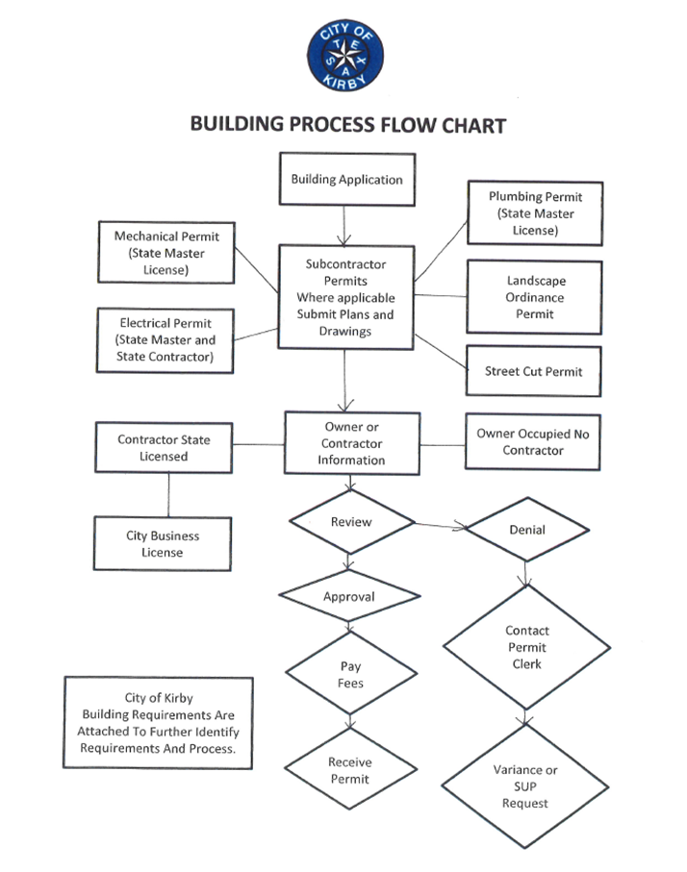
City of Kirby Building Requirements
The following items must be submitted:
- One (1) set of competed permit applications (Building, Electrical, Plumbing, and Mechanical)
- Copy of Contractors license, and bond or certificate of liability if work is performed by a contractor
- Three (3) sets of detailed blue prints (Commercial Building or New Residential Building)
- Permits applications must be approved and issued before work begins
Permit Approval
Allow two (2) weeks for plan approval on new residential construction. This time allotment is based on your entire package being complete when submitted, with all forms properly filled out and all required documents included.
Impact Fee
Impact fee shall be determined during the platting process for residential homes, and depending on the location of property, there could be additional water and/or sewer fees. Impact fees are paid at the time permits are picked up. Cost for water meter and service line are not included in the fees and will be issued at that time.
Permitting Hours Are 8:00 A.M.-4:00 P.M. at City Hall, 112 Bauman Street
Permits for Re-roof, HVAC Change out, Electrical Reconnect, Foundation Repair, Sewer Water Line, Driveway/Sidewalk Replacement and Water Heater can generally be issued the next day if submitted during the above timeframe.
If work permitted has not been started within one hundred eighty (180) days from date of issue, permit will become null and void.

